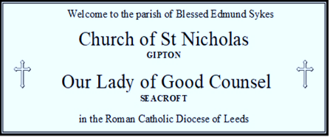

HABEMUS PAPAM
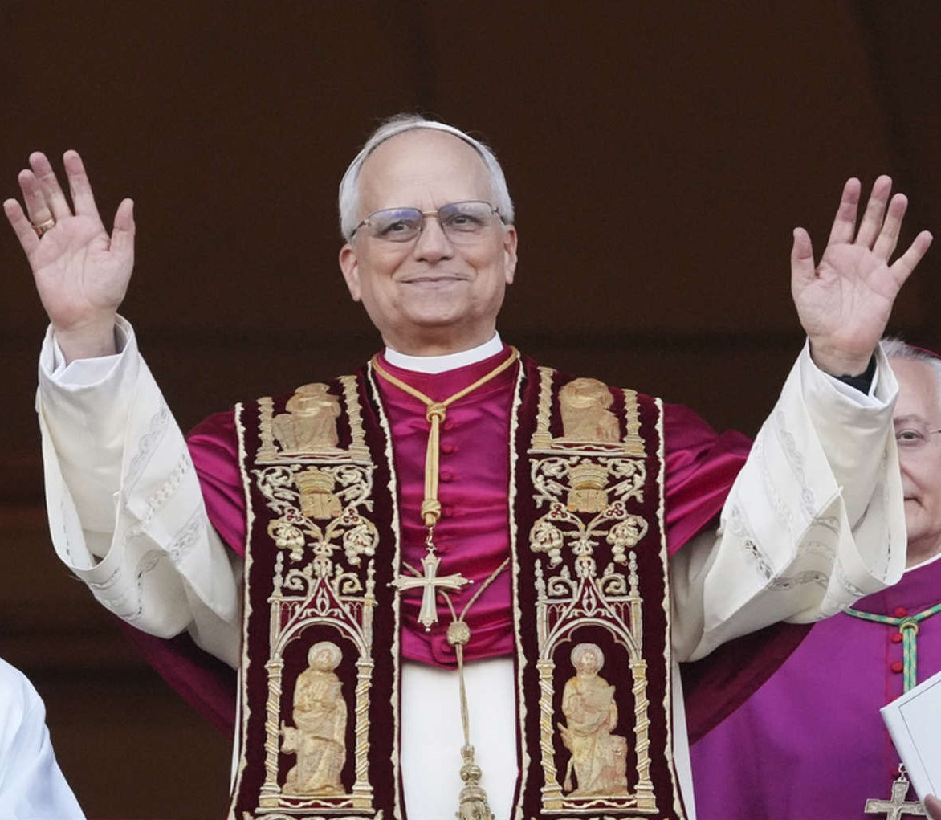

POPE LEO XIV

MASS AND ROSARY: Every Fridays of May at 7pm, there will be Mass and Rosary at St. Nicholas Church, followed by refreshments.

FIRST HOLY COMMUNION: On the 17th of May 11am at Our Lady of Good Counsel.

SACRAMENT OF CONFIRMATION BY BISHOP MARCUS: On the 20th of May 7pm at St. Nicholas Church.

MAY DEVOTIONS: The month of May as a time of honor and devotion to the Blessed Virgin Mary. Parishes and families often celebrate with special pilgrimages, and devotions.
PRAYER INTENTION MONTH OF MAY: FOR WORKING CONDITIONS: Let us pray that through work, each person might find fulfilment, families might be sustained in dignity, and that society might be humanized.

4TH SUNDAY OF EASTER
11th May 2025
This weekend | 10/05/25  SATURDAY | St Nicholas | 6pm | 4TH SUNDAY OF EASTER | Anne Joe & Pat Craven
 | 11/05/25  SUNDAY | St. Nicholas | 9:30am |  | Gerry Sheedy
 |  | Our Lady’s | 11am |  | Patrick & Kate Keane
This Week | 12/05/25  MONDAY | St. Nicholas | 9:10am | Weekday of Easter | Eric Ani  (For Successful Exam)
 | 13/05/25  TUESDAY | Our Lady’s | NO MASS | Our Lady of Fatima | NO MASS
 | 14/05/25  WEDNESDAY | St. Nicholas | NO MASS | Weekday of Easter | NO MASS
 | 15/05/25  THURSDAY | Our Lady’s | 10am | Weekday of Easter | November Deceased List
 | 16/05/25  FRIDAY | St Nicholas | 7pm | MASS & ROSARY | Pro Populo
Next Weekend | 17/05/25  SATURDAY | Our Lady’s  St. Nicholas | 11am  6pm | FIRST HOLY COMMUNION  5TH SUNDAY OF EASTER | John Henry  Peter Batt
 | 18/05/25  SUNDAY | St. Nicholas | 9:30am |  | Special Intention
 |  | Our Lady’s | 11am |  | Doreen Mullarkty

MASSED RECEIVED THIS WEEK: Doreen Mullarkty, Barrie Briggs, Kieran Sykes, Eric Ani (5), Mercedes Baylon, Terry Whitelow, Michael Joseph McNiffe, Coleman Mulkerins (Pittsburgh), Zoe Reid, Bill & Rita Smith.

THOSE IN NEED OF OUR PRAYERS: Dora Graves, Margaret Carry, John Moran, Julie Lowe, Christine O’Toole, John Haynes, Sheila Haynes, Kathleen Gaughan, Margaret Fitzpatrick, Moira Doyle, Anna Gawlik, Rachel, Adah McHugh, Josie Smith, Jane (seriously ill), Pat Doolan, Kieran Sykes and Zoe Reid.
Please remember that there is a story behind everyone named on our sick list and never stop praying for them.

Financial Stewardship:
Envelopes: £ 272.95 Loose: £357.60
Standing Orders April: £ 457

If you would like a Mass to be said on a particular date, please submit the mass request as soon as possible. There is no guarantee that a specific date will be available. And please state if you would prefer the mass to be said at Our Lady’s or St Nicholas.

LAUDATO SI’ MINI-PILGRIMAGE: Saturday 31 May. After 12 Noon Mass, walk from Leeds Cathedral to Kirkstall Abbey: https://www.dioceseofleeds.org.uk/jubilee/laudato-si-pilgrimages, bring a packed lunch. Please contact communications@dioceseofleeds.org.uk to sign up for this risk assessed walk.

LIVING IN HOPE - ONLINE REFLECTION: Wednesday 14 May 7-8pm. Leeds Diocese older people’s charity Growing Old Grace-fully is hosting an hour-long Zoom reflection exploring how living in the flow of life offers invitations to a deeper sense of hope, led by Paula Shanks and Mgr. Donal Lucey. To book email growing.old.gracefully@dioceseofleeds.org.uk

‘SPIRITUALITY OF CREATION’ RETREAT WEEKEND: 23 – 25 May, The Briery, Ilkley. Led by Margaret Siberry and the Begin with the Heart team, this retreat aims to deepen our understanding of the spirituality of creation, from early scriptures, through the wisdom of the mystics to the spiritual writers and teachers of today. £215pp fully inclusive (£85 non-residential) For more information or to book, contact the Administrator on 01943 607287 admin@briery.org.uk


Parochial Administrator: Fr Saji Kurian, MSFS Assistant Priest: Fr Jijimon Mani, MSFS
Parish Administrator: Gloria Simcox (Working hours Mondays 1-3pm, Thursdays and Fridays from 9am to 1pm)
St Nicholas Presbytery, Oakwood Lane, LEEDS, LS9 6QY
Email: office.blessededmundsykes@dioceseofleeds.org.uk; Tel: 0113 249 0429

